Constructing a Stabilizer for Curling

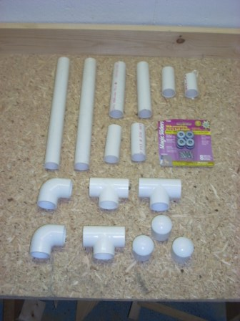
Materials:
- A section of 1” PVC pipe at least 48” long
- Three 1” Tees
- Three 1” end caps
- Two 1” 90s or elbows
- Three ¾” diameter screw attached Teflon sliders, typically used for table leg or chair leg bottoms.
- PVC solvent and cement or 5/8" long, 1/8" diameter hex head machine screws

Tools:
- Saw for cutting pipe (a hacksaw will work)
- Screwdriver
- Socket
- A square

All of the material is available at the local home store (the blue place or the orange place will work just fine) or a local hardware store. Parts are probably $20. Note that 1” pipe is 1” inside diameter and the fittings are a bit larger to fit over the outside of the pipe. To make sure you have the right parts, I suggest you test fit at the store.
Parts for Stabilizer (Pipe is Cut)

Comments About Fastening Pieces
There are two ways to fasten the PVC sections. What I used was PVC cement. The caution is that this method is quick but permanent. If you get a piece in the wrong orientation, tough. If you are not comfortable with PVC cement, follow the directions for using screws, below.

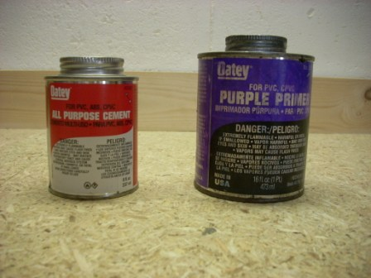
To use PVC cement, first you brush on the solvent (it's purple). Put the solvent on both parts, and you only need to put it on the sections that will be in contact. The solvent stains the PVC, your hands, your clothes and anything else it contacts so be careful. After the solvent, apply the glue. I find it works best to put the glue in the Tee, elbow or cap, not on the pipe section. This approach minimizes the amount of glue that runs all over everything. You will need to work very quickly to get pieces aligned once connected, the glue sets in about 10 seconds. One final note: the glue and the solvent smell. They probably cause brain damage or something if you inhale it too much. I strongly recommend you use it in a well ventilated space. Oh, and read and follow all directions.

The alternate approach to fastening is screws. To attach the segments with screws, fasten the pipe and the joint tightly. Make sure all pieces are properly aligned. You can fuss a bit with these, there is nothing binding them together. Take months to get them in the right set-up, if you like. Once you have them set in the proper alignment, drill a 1/16" or 3/32" pilot hole through the joint and into the pipe below. Be careful not to drill through the other side. Insert and tighten the screw. I recommend using a socket wrench to tighten. Do not over tighten, you will strip the hole and the fastener will not hold. Note that screws need to be located at places where they will not come in contact with the ice as they will scratch it, and they need to be away from where you grip the stabilizer.
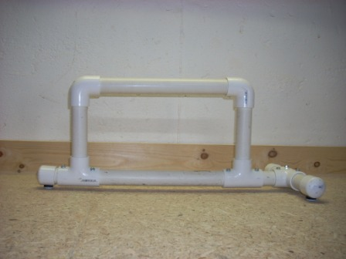
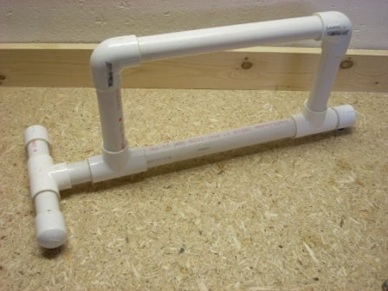
Before you start, here are photos of the finished stabilizer so you know what you are shooting for. The one on the right is attached by screws and the one on the left is attached using glue. From this point forward, I will be using the term "attach" and it will be up to you to determine how you are doing the attaching.

Assembly
Begin by cutting the PVC pipe to length. Cut the following sections:

- 2 sections 12” long
- 2 sections 6” long
- 2 sections 3 ¼” long
- 1 section 2 ¾” long; and
- 1 section 2” long

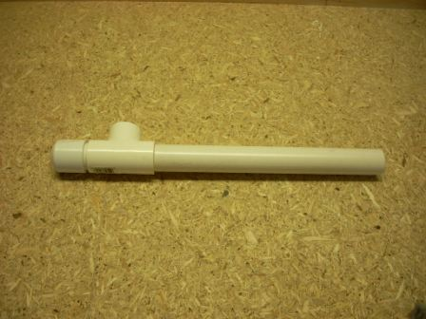
Step 1: Construct the stabilizer from the bottom first. Attach a cap section onto the 2" section. Attach a Tee on to the 2" section and attach a 12" length of pipe into the other end of the Tee. Orientation does not matter at this point; the construction is just a straight line. If you are concerned that you will get the orientation wrong, jump to Step 3 and read an alternate method.
Step 2: Next attach a second Tee to the other end of the 12" length of pipe. Now alignment matters. The two Tees MUST be oriented in the same direction. If not, you will have an unstabilizer. Again, jump to Step 3 to get an alternate approach.
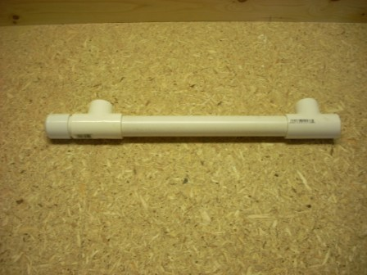

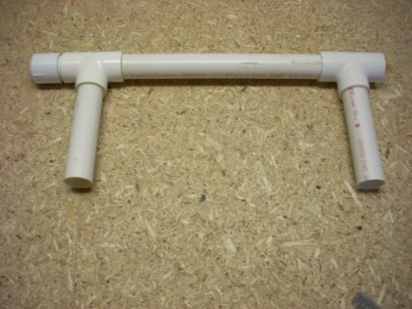
Step 3: This step is easy. Attach the two 6" lengths of pipe into the tees as shown. If it is aligned right, they will all lay flat on the table.

Alternate approach. I was comfortable attaching the Tees and eyeballing the line up. If you are not, attach the 6" pieces first in to the top of the 2 Tees, then attach to the 12" length of pipe between them. This will provide a longer "sight line" for you to use to get the parts in alignment.

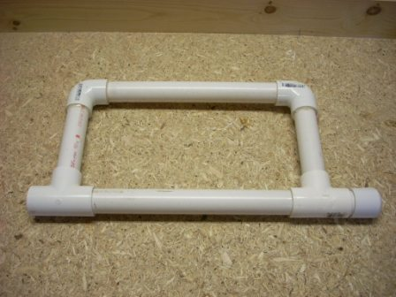
Step 4: Now it gets tricky. If you are screw attaching, this is easier, if you are gluing, think about what you are doing first. Attach a 12" section into an elbow. Then attach the elbow onto one of the 6" pieces. It does not matter which one. Line up the 12" piece and the 6" piece at the corner that is missing an elbow. This will ensure the stabilizer is square. Set this piece aside.

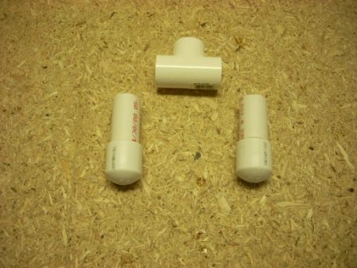
Step 5: We are now going to build the transverse piece that runs across the front of the stabilizer. Start with two caps and two 3 ¼" lengths of pipe. Attach the caps to the pipe.

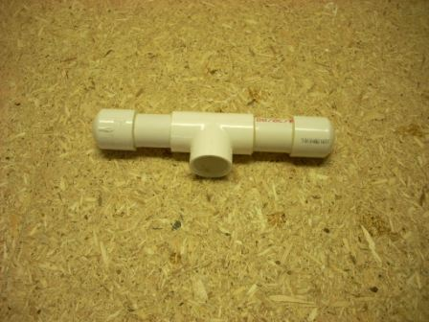
Step 5: Part two, assemble the end cap sections into the Tee. As with Step 1, alignment does not matter here. The finished section looks like the picture.

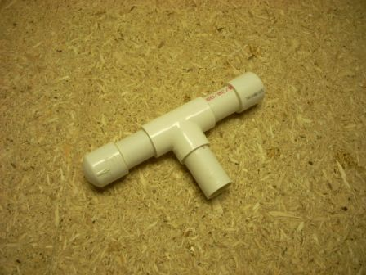
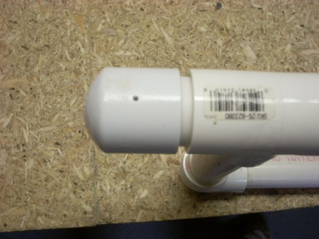
Step 6: Attach the 2 ¾" length of pipe into the Tee. This should be the last section of pipe you have not already attached to something.

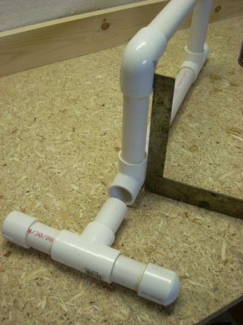
Step 7: Another tricky part. In this step we are going to attach the piece built in Step 6 to the piece built in Step 4. When you are done, it will look like a stabilizer. However, to really look like a stabilizer, it is important that the stabilizer be square. If you are gluing, you will need to attach the pieces and then before the glue sets, get the vertical portion square to the horizontal section.

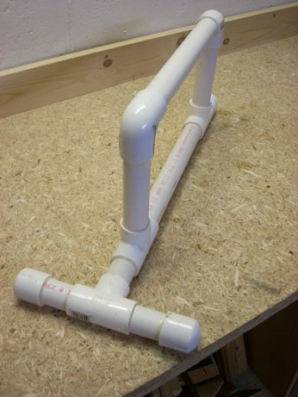
So with all that being said, attach the two pieces together.

Step 8: Attaching the Teflon sliders. Until you do this, you have a stabilizer, but it won't slide. There are three Teflon sliders attached to the stabilizer, one in of the three end caps. Use the screw on sliders instead of stick on ones. Because of the curved surface of the pipe, stick on ones will not stay put and then you don't slide. The screw on ones need to be the recessed kind, else you scratch the ice.
Start by drilling a 1/16" pilot hole in the bottom of the stabilizer in each of the three caps. Screw in the sliders. You're done. Go curl.
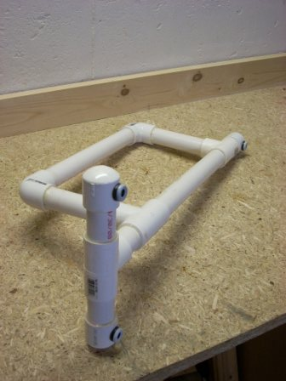
Two views of the finished product.

